Printmaking Vocabulary
- Matrix / Printing Plate: A three-dimensional relief artwork, it is the original artwork (the matrix)

- Printmaking: the transferring of an image from one surface to another

- Relief: The building up or cutting away of a flat surface to give it depth. The raised areas print.
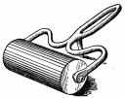
- Brayer: A rubber roller attached to a handle.
It is used to ink blocks of wood or linoleum.
The ink is rolled back and forth until it is evenly
distributed.

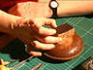
- Baren: The traditional Japanese tool for pressing
the paper against the inked block to produce a print.
It consists of a circular pad made of a braided matt
with a bamboo covering. Circular pressure is applied.
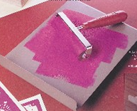
- Bench hook: A metal plate with a lip on each side,
one up and one down to fit over the edge of the
table. Used for carving blocks and rolling out ink.

- Linoleum cutters: Tool used for carving linoleum blocks. Metal tips (gouges) are inserted into the handle and are interchangeable.

- Relief print - (also called block print) A relief print works like a rubber stamp. The raised surface of the printing block is covered with ink. Paper is then pressed against this surface to produce a print. Any area that is cut away from the flat surface of the block will be white in the print because the cut-away area will receive no ink. Woodcuts and linoleum block prints are two types of relief print.

- Retarder – a chemical agent added to acrylic paint to slow the drying time

- Chatter – the areas of the cut away background that remain visible when printed

  - These can sometimes add to or detract from the final printed image depending upon how the artist handles them

Relief Block Printing : Repeated Patterns
Assignment
- Sketch 6 different patterns/designs
  - The designs can be non-objective or realistic
- Select at least 2 that you will use to print a repeating pattern on fabric
- Plan what you would like to print on
  - Options include canvas bags, muslin, burlap, etc…
  - You can make a variety of different things with this, in the past students have made placemats, table runners, pillows, bags, etc…

Sketching various pattern designs:
  - Sketch 6 different designs on the handout provided
  - Take your time to think about subject matter, color choices, paper color, fabric color, etc…
  - Please keep in mind that thin line work and small designs are very difficult to cut, make it simple!

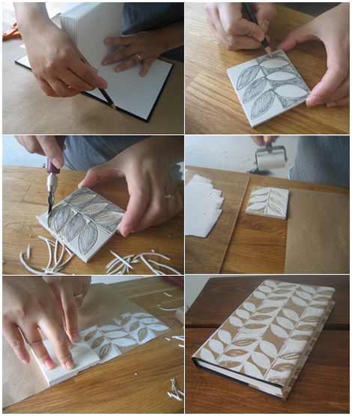

    - ALWAYS use pencil

Fraction Title Name

PRINTMAKING 101
History of Printmaking:
- Printmaking was developed in early 1400’s, around the same time paper was introduced
  - Prints were used as means to reproduce pictures or drawings over and over again, most commonly used for books
- Linoleum is man-made
  - Discovered in 1863 when a man noticed that whenever a can of paint was left open a thick rubber like surface formed on the surface. By taking that substance, mixing it with powdered cork and applying it to burlap, you can produce sheets of …linoleum.
  - There is no grain in linoleum so it gives little resistance to tools, creates artwork with smooth, clean texture.

Printmaking is a sometimes misunderstood aspect of visual art. The distinction between fine art prints and commercially reproduced prints (posters which have been signed) is not always easy to make.
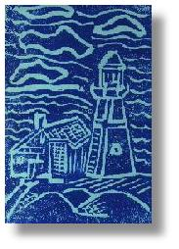
Fine art printmaking involves the creation of a master plate from which multiple images are made. Simply put, the artist chooses a surface to be the plate. This could be linoleum, styrofoam, metal, cardboard, stone or any one of a number of materials. Then the artist prepares the printing plate by cutting, etching or drawing an image onto the plate. Ink is applied (in a variety of ways) and paper is pressed onto the plate either by hand or by way of a hand-run printing press. The finished print is pulled from the plate.
Often the first three or four prints of are different than the rest of the edition. These first prints are called artist's proofs. The number of prints pulled from one plate is called an edition. Once a certain number of prints are pulled, the plate is destroyed so that more prints won't be printed later, thus ensuring the value of the edition.
At the bottom of a print are two to three things always written in pencil. On the left is a number that appears as a fraction (e.g. 6/25), this means that the print is number six of a total of twenty five prints pulled from one plate. This number excludes the artist proofs which are designated with an A/P. In the center of the bottom of the print is the title (if any). At the bottom right, is the artist's name and sometimes a date.

Relief Printing
This is printing from a raised surface. A simple example of relief printing is a rubber stamp pressed into a stamp pad and pressed onto a piece of paper. Relief printing plates are made from flat sheets of material such as wood, linoleum, metal, styrofoam etc. After drawing a picture on the surface, the artist uses tools to cut away the areas that will not print.
A roller - called a brayer - is used to spread ink on the plate. A sheet of paper is placed on top of the plate and the image is transferred by rubbing with the hand or a block of wood, or by being run through a printing press. The completed print is a mirror image of the original plate.

